Specification Document

# Product’s Capabilities

* Retrieving the file names in an ascending order
* Option to add a user specified file to the application
* Option to delete a user specified file from the application
* Option to search a user specified file from the application

# Appearance & User Interactions

## Initial Welcome Screen

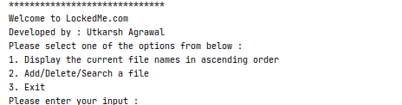

## Secondary Welcome Screen

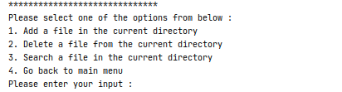

## File Creation Success Screen

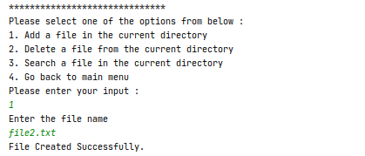

## File Creation Failure Screen

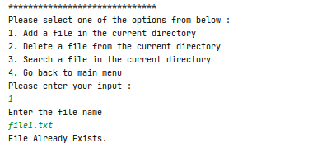

## File Deletion Success Screen

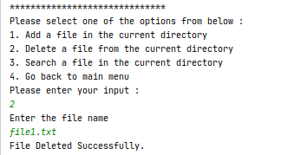

## File Deletion Failure Screen

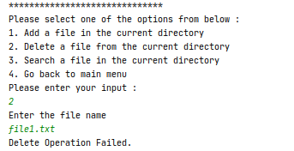

## File Search Success Screen

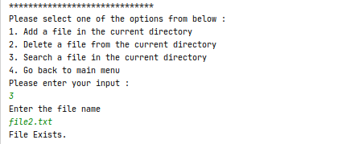

## File Search Failure Screen

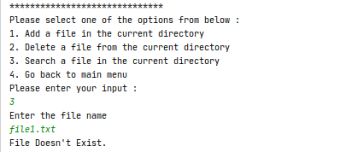

## Files In Ascending Order Screen

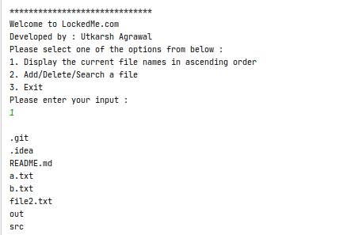

# Sprints

## Number

3 Sprints will be required.

## Duration

Each sprint will be 1 week long

## Tasks Planned

### Sprint 1

Creation of Flowchart and gathering all user requirements.

### Sprint 2

Implementation of Creation & Searching of files.

### Sprint 3

Implementation of Deletion & Sorting of files.

# Java Concepts Used

1. File I/O
2. Exception Handling
3. Console I/O
4. Sorting
5. Abstraction
6. Encapsulation
7. Collections

# Data Structures

Following data structures have been used in Searching & Sorting Applications :

1. Arrays (Fixed Size)
2. ArrayLists (Variable Size Arrays)

# Conclusions

## Future Improvements

1. Copy file contents
2. Append files
3. Edit files
4. Create multiple files
5. Delete multiple files